# Implementation

To enhance road routing and navigation in London, especially within the University of Roehampton, a traffic forecasting system is proposed to avoid inefficiencies and traffic jams. The system's architecture, depicted in Fig.1, comprises three main elements: a server, a database, and the users, refers to Appendix C for the devlopment codes/scripts and the dataset.

**3.1 System's Architecture**

1. **Geographic Information System(GIS)**

Geographic Information Systems (GIS) have been advancing since the 1970s. GIS serves as a crucial tool for location mapping, visualizing dynamic conditions, and aiding decision-making processes [32-34]. Geospatial data are instrumental in monitoring responses to accidents. During the response phase, GIS enables the analysis of real-time data, facilitating visualization and automation for more efficient decision-making. Research in GIS has concentrated on areas like shortest path analysis [35, 36]. This highlights the significant potential of GIS applications to reduce response times if geospatial information is utilized at the initial stages of accident response.

1. **Web Service**

A web service is an internet-based technology defined by the W3C as "a software system designed to support interoperable machine-to-machine interaction over a network" [37].

1. **Web GIS**

Web GIS initially offered only client access through browsers, incorporating basic GIS functions to minimize system costs. Browsers are an optimal choice because they can extensively utilize GIS, reduce software expenses, simplify operations, and provide a user-friendly interface [38, 39].

**D. System Component**

The web framework is based on a three-tier architecture consisting of the client layer, middleware layer, and database layer. These components provide a unified interface for data consultation, requests, and decision-making. The PostgreSQL database, enhanced with PostGIS, supports both relational and spatial queries. Users interact with the database via the Internet, using a web browser for navigation and spatial analysis. User requests are processed by the Apache Web Server and passed to the GIS server, which queries the database[40]. The system supports system administrators, who manage databases, and teleoperators, who handle data entry, editing, and deletion through a GUI. The system utilizes geographic data for mapping and semantic data for routing and traffic flow information.

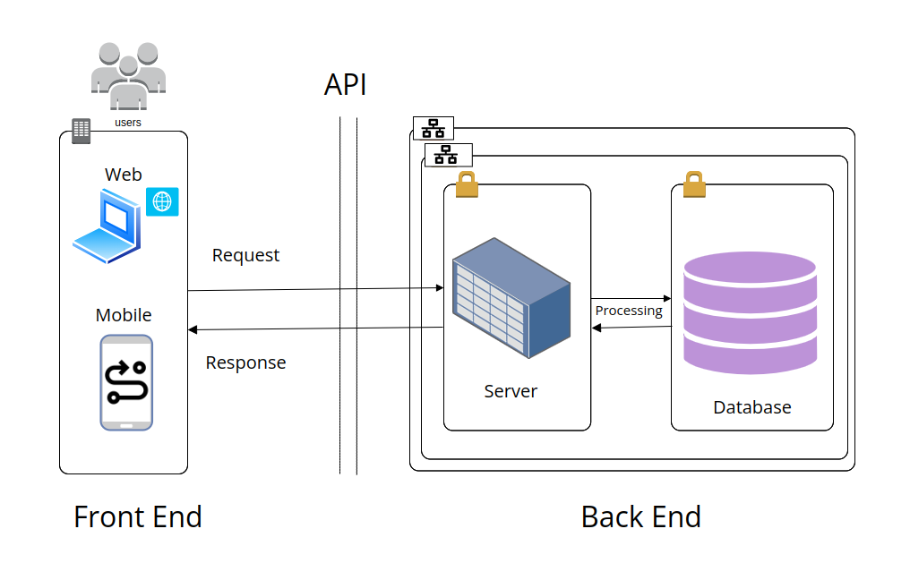

**Figure 1. System Component**

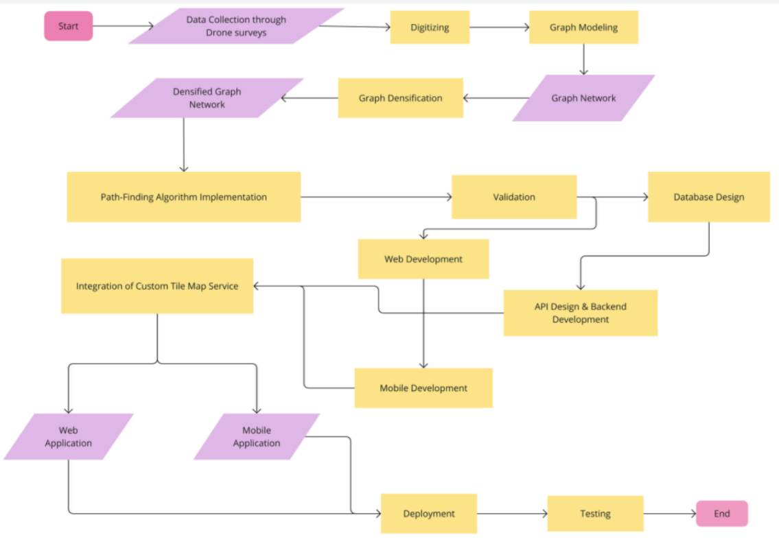

**Figure 2. System Development Flow Chart**

**3.2 Data Structure**

1. **Study Area**

The study focused on London roads and the University of Roehampton for designing and implementing a GIS-based road network navigation system. The dataset was sourced from TFL, see Appendix C1 for more details. University of Roehampton locations were digitized using QGIS.

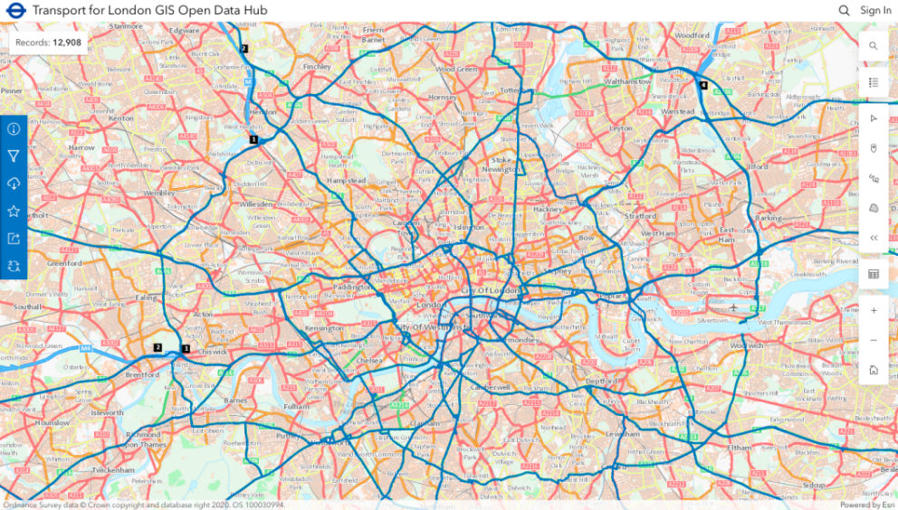

**Figure 3. London Road Network(TFL)**

1. **GIS Layers**

The Global Positioning System (GPS) is used to collect longitude (X) and latitude (Y) values, identifying the geographic locations of monitoring sites. The application is based on real data embedded in maps as layers. The spatial data include roads, street names, and monitoring site locations. There are several distinct layers: the road layer, city layers, and the road connection network layer. Roads are represented by polylines, while street names and monitoring stations are represented by points. City names, also represented by points, are placed on the road line to enable plugin routing operations. The "cities" table currently contains a few test names, with more to be scanned and added in future application updates.

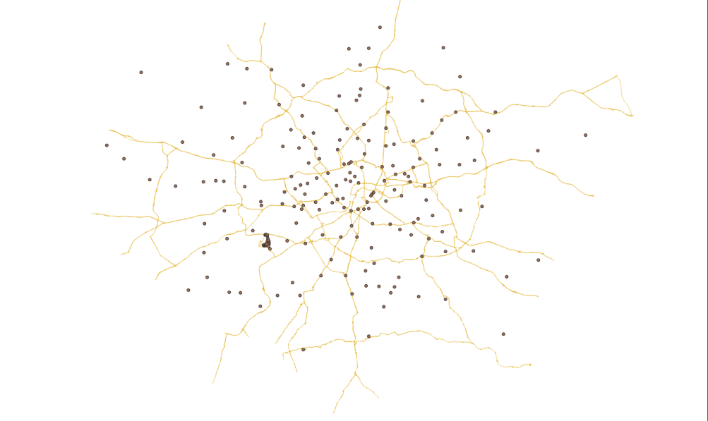

**Figure 4. London Road and Cities(QGIS)**

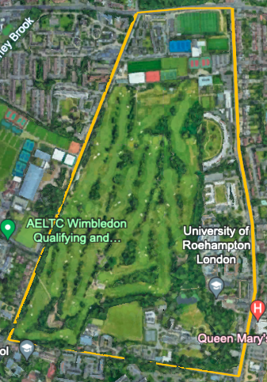 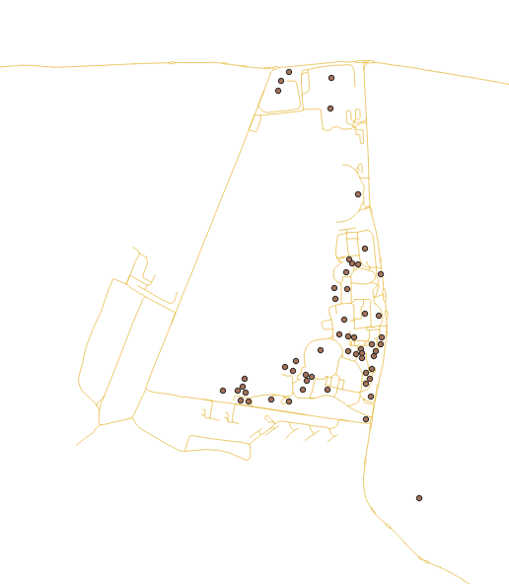

**Figure 5. University of Roehampton routes(Google Earth)**

1. **Graph Modeling**

The graph network, digitized and cleaned using QGIS, is modeled with Python to provide a comprehensive representation of the London road network. This model includes both visual and data aspects, capturing the intricacies of the network through nodes (representing intersections) and edges (representing road segments). The resulting graph is ready for further processing and analysis, enabling advanced functionalities such as route optimization, traffic forecasting, and network efficiency studies. This detailed graph model serves as a foundational tool for enhancing navigation and traffic management systems in London, offering precise and actionable insights into the road network.

1. **Graph Densification**

The graph will be densified by adding intermediate nodes and refining edges to enhance path-finding accuracy and efficiency. This process results in a more detailed and precise representation of the road network, ensuring better navigation and traffic management. By incorporating additional nodes and adjusting edges, the graph model can capture the finer details of the network, leading to improved route calculations and more reliable traffic predictions. The densified graph thus offers a robust foundation for various applications, including advanced GIS analyses, real-time traffic updates, and optimized route planning, significantly benefiting road users and urban planners.

**3.3 System Development**

1. **Database Design**

A comprehensive database design using PostgreSQL with PostGIS will be developed to efficiently store and manage spatial and attribute data. This approach ensures robust and scalable data management, accommodating the complexities of spatial data such as road networks, intersections, and monitoring sites. By leveraging PostgreSQL's powerful database capabilities and PostGIS's spatial data handling features, the system will support advanced queries, spatial analyses, and real-time updates. This design will facilitate seamless integration with other GIS tools, enhance data integrity, and provide a solid foundation for ongoing system enhancements and data-driven decision-making processes.

1. **Backend Development**

The backend will be developed to manage data processing, implement pathfinding algorithms, and handle database interactions. This will involve setting up servers and API endpoints to facilitate secure and efficient data transactions. The backend infrastructure will be designed to support real-time data updates, query execution, and integration with the frontend, ensuring a seamless user experience. By focusing on robust server architecture and optimized data handling, the backend will enable efficient processing of spatial data, accurate route calculations, and reliable communication with the database, ultimately enhancing the overall performance and scalability of the navigation system.

1. **Web Development**

A web interface using React will be developed to display optimal routes on a digital map of London. This interface will be designed for accessibility via computers, ensuring ease of use for all campus members. The goal is to provide an interactive and responsive experience, allowing users to view and interact with real-time traffic data and optimal routes efficiently. The web application will feature intuitive navigation, real-time updates, and user-friendly design elements, making it a valuable tool for navigating the campus and surrounding areas. By leveraging React's capabilities, the interface will offer a seamless and engaging user experience.

1. **Integration of Custom Tile Map Service**

The application will integrate a custom tile map service to provide high-resolution drone imagery, ensuring seamless and efficient map rendering. This integration will enhance user interaction by offering detailed and accurate visual representations of the area. The high-resolution imagery will facilitate better route visualization and navigation, improving the overall user experience. By utilizing a custom tile map service, the application will maintain fast loading times and smooth performance, allowing users to interact with the map effortlessly and access up-to-date visual information with ease. This feature will significantly enhance the application's functionality and appeal.

**3.4 Implementation**

The chosen tools are open-source solutions like MapServer, Leaflet, and PostgreSQL, which provide functionalities comparable to commercial options but at a reduced setup cost. This application is designed with the assumption that users (decision-makers) lack a background in modeling or implementation. Therefore, the information presented to them is straightforward and user-friendly, avoiding technical or conceptual details.

To develop the application, an Object-Oriented (OO) methodology, Python Dijkstra’s algorithm will be implemented in Python, Go, and JavaScript to calculate the shortest paths on the graph SQL for the database. The application features a main window where all functionalities are accessible via a toolbar or menu, making it easy for users to navigate, see Appendix C2 for more details.

The target users are decision-makers with moderate computer skills, emphasizing the need for an intuitive interface. The tool is divided into two subsystems:

- A subsystem for entering location name, editing, or delete road network data

- A subsystem for managing geographic data display

The tool includes a set of graphical user interfaces and is designed for web platforms. Its open architecture facilitates the easy addition of new functionalities.

**A. Graphical User Interface (GUl)**

The primary goal of the GUI was to facilitate easy and efficient access. According to [41], the following characteristics are essential:

- Easy to learn: Ensures that any user can intuitively use the tool.

- Robustness: Allows users to recover from unintended situations.

- Interactivity: Enables effective information flow between the user and the system.

- Event-based: Keeps users constantly aware of the tasks they are performing.

1. **Tools**

The semantic database is managed by the PostgreSQL database management system. Graphic layers obtained with GIS from the digitization of University of Roehampton routes and the London road network are imported into the Oracle spatial DBMS: PostGIS. Utilizing this Oracle spatial DBMS allows interaction with the mapping module of the web server: Leaflet.

1. **Decision Model**

The web serves as the primary interface for connecting users to the system. The teleoperator uses a Graphical User Interface (GUI) to simplify the interpretation of information, enabling them to (Figure 6):

- Control Layers: Toggle the visibility of certain layers.

- Map Operations: Perform actions like zooming in, zooming out, expanding, planning, and querying specific areas of the map to gain a better understanding of the data in those regions.

- Focus on London: Directly center on the London road networks.

- Scale Visualization: View the map at different scales by changing the representation scale.

- Map Reference: Display a reference map for easier location identification.

- Full Caption Layers: Show comprehensive caption layers.

- Database Query: Utilize drop-down lists and checkboxes to query the database, or directly use SQL (Structured Query Language) statements for a combination of relational and spatial queries.

- Spatial Queries: Perform spatial queries in various ways, such as clicking the search box to query map objects or by entering the identifier, designation, or X and Y coordinates of a post, with results transmitted to the user as an XML document via the web.



**Figure 6. Welcome window((GUI)https://london-navigator.netlify.app**

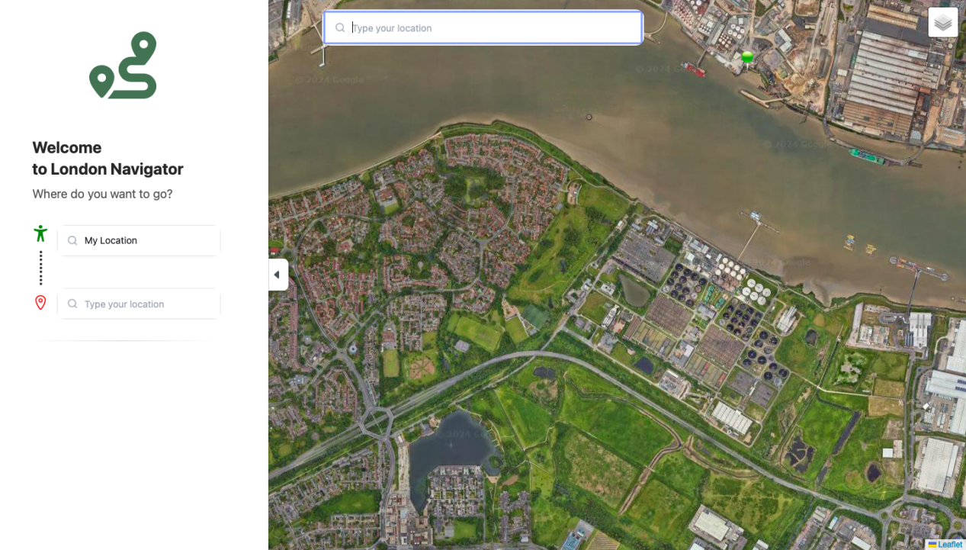

**Figure 7. Operation window(https://london-navigator.netlify.app/map)**

**3.5 Implementation of Dikstral’s Algorithm**

**A. Dijkstra's algorithm**

Incorporating an efficient shortest-path algorithm within the GIS will reduce time spent on the road network and address navigation inefficiencies. The optimal routes are those with the minimum required transportation times. A real-time system must be capable of providing prompt responses to such queries.

In the London Navigator, the experimental system developed for this project, the routing service is implemented using Dijkstra's algorithm. This spatial optimization algorithm is widely used in GIS software for finding the shortest routes. Its performance relies on the data structures used to implement the graph representing the spatial network [42]. The road network is represented by a graph (non-oriented in this case), where each intersection on the physical road is depicted as a node.

Let G = (N, A) be a graph consisting of a set of nodes (N) and a set of arcs (A), each with a non-negative cost C. This graph is designed for tracing the least-cost path (route) in G. For a given destination node in the network, Dijkstra's algorithm calculates the least accumulated cost between the destination node and every other node, then finds the least-cost path from any origin node to the destination node. The logical procedure of Dijkstra's algorithm is as follows [43]:

1. Let the node at which we are starting be called the source node. Assign to the source node an initial value of zero and to all other nodes an initial value of infinity. Mark all nodes as unvisited. Set the source node as current.

2. For the current node, consider its unvisited neighbors directly connected by links having cost values and calculate their accumulated costs from the source node. If the new accumulated cost is less than the previously recorded cost, overwrite the cost.

3. When all neighbors directly connected to the current node are completely considered, mark the current node as visited. A visited node will not be checked again, ensuring its accumulated distance is final and minimal.

4. If all nodes have been visited, finish. Otherwise, set the unvisited node with the least accumulated cost to the source node as the next "current node" and continue from step 2.

Dijkstra's algorithm is very similar to the A* algorithm. The cost function c used to evaluate shortest paths in the Dijkstra algorithm is augmented by an estimator function, which estimates the shortest path between two given graph nodes. This is represented as c(s, d) = g(s, v) + h(v, d), where g(s, v) is the cost from source s to v, and h(v, d) is the heuristic estimated cost from v to the destination d. The estimator function is a heuristic that can be chosen arbitrarily. If the estimator function is 0, A* turns into Dijkstra's algorithm [43].

1. **Simulated test cases and routing**

The algorithm was implemented in Python within a web environment hosted on [Render](https://render.com), which manages the backend, including the database and server operations. Render not only facilitates the handling of road maps online through user-friendly interfaces, but also supports the implementation of the "pgrouting" plugin, which runs on both the client and server sides. The frontend, responsible for the user interface, was hosted on Netlify and developed using Go language. The interface is designed with an intuitive template for easy and effortless use, as illustrated in the provided image[figure 6].

Users can view specific locations on the map by entering the name of the location. Additionally, they can determine the shortest route to a destination by specifying the starting and ending points. The algorithm then computes and displays the shortest route on the map. Whenever a routing operation is performed, the location names are passed as parameters from the client interface to the server. The server connects to the database, processes the request, computes the shortest path between the specified points, and highlights it on the map with a distinct color, see figure 7.

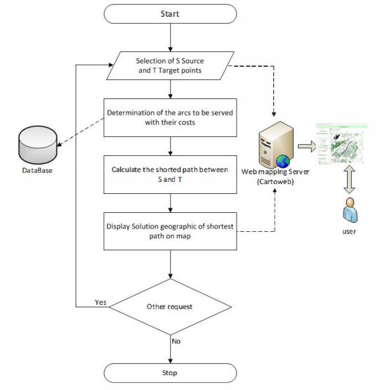

**Figure 8. The proposed routing solution with Dijkstra's algorithm.**

1. **Test Case 1: Routing Problem at the University of Roehampton**

In this scenario, we have a user named Aman Richard, a 29-year-old MSc Data Science student at the University of Roehampton, London. Aman resides at Southlands Chapel, located within the university campus. One day, he decided to go for a workout at the university gym. His fellow student recommended the Oliver Garnet-ROEactive Gym, which is situated on campus. However, Aman was unfamiliar with its exact location.

To solve this problem, Aman decided to use the "London Navigator," a tool recommended by his peer for optimizing the shortest routes on London roads, including those within the University of Roehampton campus. Using the system, Aman entered his starting point (Southlands Chapel) and his desired destination (Oliver Garnet-ROEactive Gym). The system quickly computed and provided the shortest route, complete with clear path-guiding hints displayed on the map.

Thanks to the London Navigator, Aman was able to navigate effortlessly to the gym, something that Google Maps could not achieve due to its limitations in recognizing specific campus locations. Consequently, Aman’s problem was resolved efficiently with accurate routing provided by the system, see figure 8.

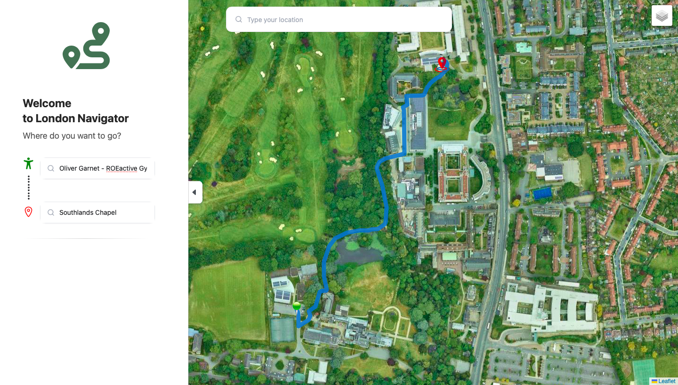

**Figure 9. Southlands Chapel to Oliver Garnet-ROEactive Gym**

1. In **Test Case 2: Locating a Lecture Class Building at the University of Roehampton**

this scenario, Dr. John Carter, a newly employed lecturer at the University of Roehampton, faces a challenge. On his first day, Dr. Carter arrives at the university's main entrance, ready to deliver a lecture. However, he struggles to locate the Sir David Bell Building, where his lecture is scheduled to take place. Unfortunately, Google Maps does not provide the precise location of this building within the campus.

To resolve this issue, Dr. Carter decides to use the "London Navigator," a tool designed for optimizing routes both within London and specifically on the University of Roehampton campus. At the main entrance, Dr. Carter inputs his current location and sets the Sir David Bell Building as his desired destination.

The London Navigator quickly calculates the shortest route, providing Dr. Carter with a clear and detailed path to follow. Thanks to the accurate guidance from the system, Dr. Carter is able to navigate through the campus and arrive at the Sir David Bell Building promptly, ensuring that he is on time for his lecture.

This case highlights the effectiveness of the London Navigator in addressing routing challenges that conventional map services, like Google Maps, may not fully support within specialized environments such as a university campus, see figure 9.

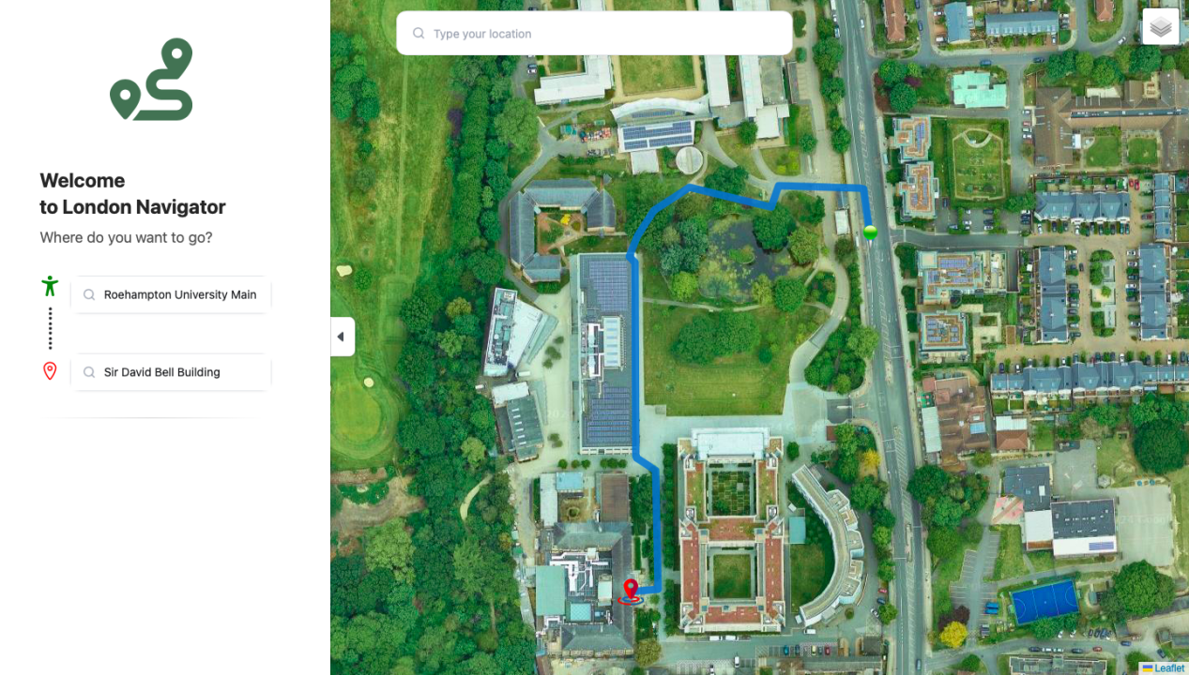

**Figure 10. University of Roehampton Main Entrance to Sir David Bell Building**

1. **Test Case 3: Delivering Pizza to the University of Roehampton**

In this scenario, Tom Bennett, a dispatch delivery man, is tasked with delivering a pizza to a student waiting at the main entrance gate of the University of Roehampton. Tom is currently in Putney, a nearby area, and needs to find the quickest and most efficient route to the university's main entrance.

To ensure timely delivery, Tom decides to use the "London Navigator," a specialized tool designed to optimize routes within London, including routes leading to the University of Roehampton. Tom inputs his current location in Putney as the starting point and the University of Roehampton main entrance gate as his destination.

The London Navigator promptly calculates the shortest route, offering precise turn-by-turn directions. This guidance allows Tom to avoid potential traffic delays and navigate directly to the university with ease. As a result, he is able to deliver the pizza to the student on time, ensuring customer satisfaction.

This scenario demonstrates the utility of the London Navigator in aiding delivery personnel by providing them with the most efficient routes, particularly when conventional navigation tools might not offer the same level of detail or accuracy for specific locations, see figure 10. see [ Appendix C 2]

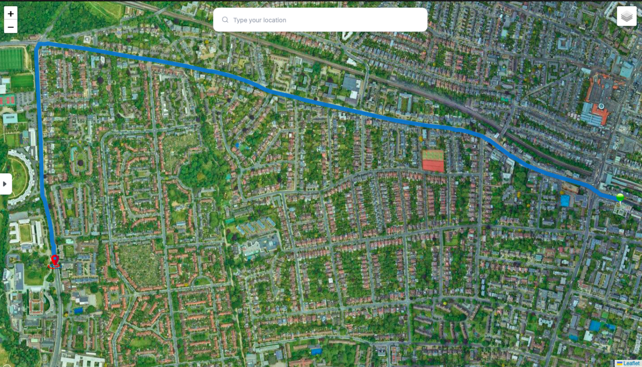

**Figure 11. Putney to University of Roehampton Main Entrance Gate**

# Evaluation and Results

To validate the effectiveness of the designed traffic forecasting system, a demonstration was conducted using a web-based client interface. This interface serves as a proof of concept and can be adapted for end-user applications, such as mobile apps, web browser extensions, or integrations with GPS navigation platforms. The client interface grants access to the user’s geolocation and allows for the creation of a route by specifying either the current location or a different starting point, along with the desired destination.

The system dynamically generates a route based on the real-time traffic situation at the moment of the request, integrating google map API to forecast potential congestion by impementing dijkstra algorithm. The generated route aims to minimize travel time by choosing the optimal path under current and predicted traffic conditions. Initially, the system was trained using a manually set historical dataset to simulate traffic conditions and refine the the routing by digitising some missing network link within the system.

One of the system's key features is its ability to adapt to changing traffic conditions during a trip. If the traffic situation alters while the driver is on the road, the system can recalculate the route in real time to maintain the shortest possible travel time. The accuracy of the forecasts is continually evaluated by comparing predicted traffic conditions with the actual outcomes. This feedback mechanism allows the system to learn and improve its predictive accuracy over time, ultimately enhancing route optimization to achieve reduced travel times and alleviate congestion.

To quantify traffic congestion, the system utilized the condition 14≤ n ≤ 20 for d = 60, where n is the number of vehicles and d represents the length of the road segment under study. This criterion assumes that a traffic jam forms when there are between 14 and 20 vehicles within a 60-meter stretch of road.

Additionally, the system leveraged the Google Maps API to calculate the number of markers (vehicles) in a specific neighborhood of the London road network. This data on inflow and outflow across the network aids in forecasting routes that result in reduced travel times. The application of this system within the London road network, including the University of Roehampton area, demonstrated its potential to optimize routes, thereby contributing to a more efficient transportation system.

To numerically assess the benefits of the designed traffic forecasting system, the system was tested on approximately 10 different routes under varying traffic conditions, including scenarios with different levels of congestion. The evaluation aimed to quantify the time savings achieved by using the forecasting system compared to not using it.

The following metrics were used:

- t1: Time required to complete the route without using the traffic forecasting system.

- t2: Time required to complete the route using the traffic forecasting system.

- Δt: The time difference between completing the route without and with the forecasting system, expressed as a percentage.

Δt = $\frac{t1−t2}{t1}×100$..........................................................................(1)

This formula calculates the percentage of time saved by utilizing the forecasting system. The results from the test routes provided a range of time gains, highlighting the effectiveness of the system in optimizing travel times under different traffic conditions.

Using table 1 which contains the test result of 10 different route by using the forecasting system and without forecasting system. To calculate change of time of travel (Δt) at the minimum fixed gain in time travel within the network by using equation(1),

t1 = 25, t2 = 15

${Δt}_{min}=\frac{t1−t2}{t1}×100$ = $\frac{25−15}{25}×100$

${Δt}_{min}=40\%$......................................................(2)

To calculate change of time of travel (Δt) at the maximum fixed gain in time travel within the network by using equation(1),

t1 = 60, t2 = 45

${Δt}_{max}=\frac{t1−t2}{t1}×100$ = $\frac{60−45}{60}×100$

${Δt}_{max}=25\%$..................................................................(3)

The above calculations demonstrate the efficiency of using the developed system of road traffic forecasting, namely, the following gains in time from 25% to 40% (average values).

|  |  |  |  |
| --- | --- | --- | --- |
| Nodes | Routes | Total Time with Routing System | Total Time without Routing System |
| N1-N2 | Acton- Algate | 20 | 25 |
| N2-N1 | Algate- Acton | 18 | 27 |
| N2-N3 | Algate - Anerly | 45 | 58 |
| N3-N2 | Anerly - Algate | 42 | 60 |
| N3-N4 | Anerly - Balham | 25 | 40 |
| N4-N3 | Balham - Anerly | 23 | 38 |
| N4-N5 | Balham - Battersea | 15 | 30 |
| N5-N4 | Battersea - Balham | 17 | 38 |
| N5-N6 | Battersea - Bayswater | 20 | 30 |
| N6-N5 | Bayswater - Battersea | 18 | 35 |

**Table 1**

In the histogram shown in Fig. 12 presents the time gain for overcoming a route laid without a forecasting system and with a forecasting system (10 routes were considered), while Fig.13 represent the total time gain by using the forecasting system in the 10 test experiment. The obtained results show the expediency of using the designed system for vehicles in urban conditions.

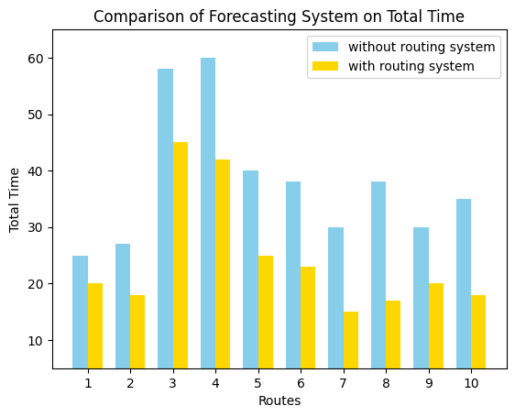

**Fig. 12**

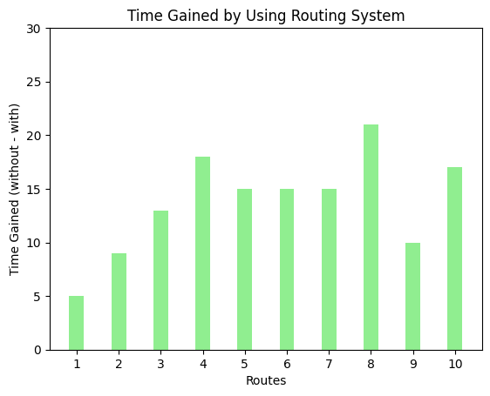

**Fig. 13**

The selected test cases included routes with both minimum and maximum time gains. These cases illustrated the variability in the system's performance, depending on the severity of traffic congestion. In scenarios with heavy congestion, the time savings were more pronounced, demonstrating the system's capacity to significantly reduce travel times by predicting and avoiding traffic jams.

In summary, the evaluation confirmed that the traffic forecasting system consistently provided time savings, with the magnitude of these savings dependent on the traffic conditions encountered on each route. This demonstrates the practical value of the system in real-world applications, offering potential improvements in commute efficiency and reductions in overall travel time.

## Related Works

In the domain of traffic forecasting and route optimization, numerous approaches have been proposed to enhance the accuracy and efficiency of transportation systems. A noteworthy contribution is the work by Souad El Houssaini and Abdelmajid Sadri, titled "A Web-Based Spatial Decision Support System for Effective Monitoring and Routing Problem." Their research presents an integrated framework that leverages Geographic Information Systems (GIS) combined with a Relational Database Management System (RDBMS) to improve the monitoring and management of road networks[44] .

El Houssaini and Sadri's system utilizes GIS technology to collect and analyze geographic data related to road networks and monitoring stations. Their framework not only identifies optimal routes based on minimum cost using Dijkstra's algorithm but also supports the strategic placement and orientation of monitoring stations in response to road incidents. The integration of diverse datasets and advanced information retrieval within a GIS environment demonstrates the system's potential to manage complex spatial data and optimize routing decisions effectively.

The effectiveness of their system was tested on the road network of Mohammedia City in Morocco, where it demonstrated significant improvements in response to road accidents through simulated test cases. The proposed system, described as scalable and well-structured, serves as a comprehensive tool for traffic monitoring and routing, particularly in scenarios requiring rapid and efficient intervention.

When compared to the current project on traffic forecasting and route optimization in London and the University of Roehampton, El Houssaini and Sadri's work offers valuable insights into the use of GIS and algorithmic methods for managing and optimizing road networks. While their research focuses on the integration of GIS with RDBMS and the application of Dijkstra's algorithm for routing, the current project builds on these methodologies by incorporating real-time traffic data and Google Maps API. This extension aims to dynamically predict traffic patterns and optimize routes, addressing the specific challenges of London's intricate road network.

Another significant contribution to the field is a study presented at the 1st International Conference of Information Technology to Enhance E-Learning and Other Applications (IT-ELA 2020), hosted by Baghdad College of Economic Sciences University. This study explored the application of parallel computation methods to solve the shortest path problem in vehicular networks [45].

In their paper titled "A Parallel Implementation Method for Solving the Shortest Path Problem for Vehicular Networks," Emad H. Al-Hemiary and Salim A. Mohammed Ali from Al-Nahrain University in Baghdad, Iraq, investigated the complexities of finding the shortest paths in mobile and densely populated vehicular networks. The authors applied Hedetniemi's Algorithm, a well-known method for calculating multi-source multi-destination shortest paths, and enhanced its computational efficiency using OpenCL (Open Compute Language).

Their research demonstrated a substantial acceleration in path calculation, achieving a 40x speedup when utilizing parallel computation compared to a sequential approach. This acceleration was particularly evident when handling high-dimensional input data, making the system more responsive and scalable for real-world applications. This study highlights the importance of leveraging parallel computing techniques to address the computational challenges inherent in vehicular networks, a goal that aligns closely with the objectives of the traffic forecasting system developed in the current research.

These related works underscore the ongoing advancements in traffic management and the potential of integrating advanced computation methods and real-time data to further optimize route planning systems. Such innovations contribute significantly to the overall efficiency and responsiveness of modern transportation networks.

# Conclusion

The "London Navigator" system, designed for traffic forecasting and route optimization within the London road network, including the University of Roehampton, has proven to be an effective tool for addressing specific routing challenges that conventional map services may not fully support. Through a series of test cases, the system demonstrated its capability to provide precise and efficient route guidance in scenarios that involved navigating within complex environments like university campuses, see [ Appendix C 1] for more details.

Test Case 1 highlighted the system's effectiveness in helping Aman Richard, an MSc Data Science student, navigate from Southlands Chapel to the Oliver Garnet-ROEactive Gym within the University of Roehampton. The London Navigator successfully provided a short and clear route, overcoming the limitations of conventional tools like Google Maps, which struggled to recognize specific campus locations. This case illustrated the system's practical value in enhancing campus navigation.

Test Case 2 involved Dr. John Carter, a new lecturer at the University of Roehampton, who needed to locate the Sir David Bell Building for his lecture. The London Navigator again proved its effectiveness by quickly guiding him through the campus, ensuring he arrived at his destination on time. This case emphasized the system's utility for university staff and visitors, ensuring timely and accurate navigation across the campus.

Test Case 3 demonstrated the system's broader applicability by assisting Tom Bennett, a delivery man, in finding the quickest route from Putney to the University of Roehampton's main entrance. The London Navigator enabled Tom to avoid traffic delays by choosing route that is not congested and deliver his pizza on time, underscoring the system's relevance for logistics and delivery services operating within the London area.

The system's effectiveness was further validated through a rigorous evaluation process, where it consistently provided time savings, particularly in scenarios with heavy traffic congestion. The test results confirmed that the London Navigator could significantly reduce travel times by dynamically predicting traffic patterns and optimizing routes. The system's integration with real-time traffic data and its use of advanced algorithms, such as Dijkstra's algorithm, allowed it to outperform conventional navigation tools, particularly in specialized environments.

In conclusion, the London Navigator represents a significant advancement in traffic forecasting and route optimization within urban settings. Its ability to adapt to real-time traffic conditions and its successful application in diverse test cases within the University of Roehampton highlight its potential as a valuable tool for improving navigation efficiency in complex environments. The system not only offers practical benefits for everyday users but also contributes to reducing congestion and improving overall transportation efficiency within the London road network.

## Future Work

Building on the successful implementation and evaluation of the London Navigator system, several enhancements are planned to expand its functionality and further improve its effectiveness in real-world applications.

One of the key areas for future development is the integration of GPS capabilities into the system. By incorporating GPS technology, the London Navigator can be transformed into a robust device tracker, allowing users to monitor the real-time location of their devices within the network. This feature would be particularly useful for applications such as fleet management, where it is crucial to track the location and movement of vehicles to optimize routes and improve overall efficiency.

Another significant enhancement involves the addition of a feature to identify congested regions within the network. The system will be upgraded to provide real-time indications of traffic congestion, enabling users to visualize problem areas on the map. Alongside this, the system will suggest alternative routes to help users navigate around congested zones effectively. This feature aims to reduce travel times further and alleviate traffic congestion by guiding users away from high-traffic areas and onto less congested paths.

These planned enhancements will significantly extend the utility of the London Navigator, making it not only a powerful tool for route optimization but also an essential asset for real-time traffic management and device tracking. The integration of GPS and the ability to indicate and avoid congested regions will ensure that the system remains at the forefront of urban traffic management solutions, offering users a comprehensive and adaptable tool for navigating complex road networks.

## Reflection

Working on this project has been a deeply rewarding experience, offering both challenges and opportunities for growth. The process of developing the London Navigator system not only allowed me to explore an area of personal interest but also significantly expanded my technical skills and knowledge in the field of traffic forecasting and route optimization.

One of the most valuable aspects of this project was the hands-on experience I gained with Geographic Information Systems (GIS) tools, particularly QGIS. Through this, I learned how to digitize road networks, a critical skill that enabled me to construct accurate representations of London's complex road system. This experience was pivotal in laying the foundation for the project, as it allowed for the precise mapping of routes and the integration of real-time traffic data.

I also acquired practical knowledge in graph construction using data from Transport for London (TfL). This involved creating a network model that could be efficiently navigated by algorithms, further deepening my understanding of the underlying structures that drive traffic management systems. Implementing Dijkstra's algorithm on the London road network was another significant milestone in this project. This task challenged me to apply theoretical concepts in a practical context, enhancing my problem-solving skills and reinforcing my understanding of algorithmic efficiency.

The project goals were met largely because of my passion for this area of study. My previous work on a smaller-scale project in the same domain provided a strong foundation, enabling me to expand the scope to a larger network system with confidence. This continuity allowed me to build on my earlier successes and apply lessons learned to this more ambitious undertaking.

In hindsight, while I am pleased with the outcomes, there are a few aspects I would approach differently if given the chance. Although the project was successful, I realized that more extensive initial planning around data acquisition and integration could have streamlined some of the later stages of the project. Additionally, incorporating user feedback earlier in the development process might have helped refine the user interface and overall functionality of the system.

Overall, this project has been a significant learning journey, equipping me with new skills and deepening my understanding of traffic forecasting and route optimization. The experience has reinforced my passion for this field and has provided a strong foundation for future work and research in this area.